|  |  |
| --- | --- |
|  | **2011** |
|  | [Type the company name]  Bryan W. Stockberger |

|  |
| --- |
| **[Type the document title]** |
| [Type the abstract of the document here. The abstract is typically a short summary of the contents of the document. Type the abstract of the document here. The abstract is typically a short summary of the contents of the document.] |

Cogeneration has the potential to increase the efficiency of any power cycle by using the same fuel source to simultaneously produce electricity and heat. This boost in efficiency can prove itself to be a worthwhile investment opportunity, according to a system’s thermo-economic structure. Cogeneration is a process whereby waste heat energy is recycled to provide heat input to another portion of a power cycle. In a Brayton cycle, heat extracted from the turbine has the capacity to heat the working fluid in another portion of the cycle in an effort to increase thermal efficiency. Modern day power-plants operating on a Brayton cycle require that the turbine stage extract as much work as possible out of the thermal fluid at an elevated pressure, expanding the fluid to a lower pressure (Schmidt et. al, 2006). By optimizing the amount of heat extracted at different stages of the power cycle, the realization is made that power systems increase efficiency and minimize exergy destruction by applying a cogeneration system.

Overall system efficiency is affected by cogeneration since the system recycles some of its own energy. By using the waste energy exhausted from the turbine in a Brayton Cycle to power another process in the cycle, the operating costs to power the system decrease and thermal pollution is reduced. Questions that arise when implementing a cogeneration system is whether or not to maximize the thermal efficiency of the system, which in turn decreases the profitability of the overall system; or to regulate the temperature of the waste steam to a range that is more profitable. There are stable ranges between operating cost and thermal efficiency for a cycle, each system is tailored to suit the energy needs of the region.

There are different scenarios that cogeneration is capable of providing an increase in efficiency. These processes include those with no cogeneration, thermal-match cogeneration, electrical-match cogeneration, or maximum cogeneration. “No cogeneration” exists when thermal energy is generated entirely for use by the cycle, meaning that all electrical power is purchased from a utility company and none is generated from heat. “Thermal-match” cogeneration produces thermal energy at temperatures and pressures much higher than that required for the power cycle processes. Electric power is generated by the steam at elevated conditions, afterward recovering the steam for use in generating power. The cogeneration system is sized so that thermal energy generated from the system is just enough to meet the demands of the cycle. In “electrical-match” cogeneration, thermal energy is again produced at elevated temperatures and pressures, similar to the thermally matched case. Electrical power is produced first with the steam, and the recovered steam is then used to power the cycle. The difference in this cogenerative effort is that now the cogeneration system is sized to meet electrical power demands of the cycle. Finally, “maximum cogeneration” exists when thermal energy is produced in excess of the cycle. Once electrical power demand is met from producing excess steam, the remainder of steam is dumped to the heat sink, usually the atmosphere. This cogeneration system is sized for maximum economic gain, such as maximum cash flow, or minimal fuel investment (Hu, 1985).

State of the art design and analysis of existing systems has led to development of more efficient technology. Cogenerative systems implemented into existing power-plants take into account various system characteristics. Some generalized parameters include fuel chargeable to electric power, overall system efficiency, electricity per steam flow, minimum process steam required, emission problems, capital costs, gross payback period, unit size and operational lifetime (Hu, 1985). These standards can be critiqued based on a cost/benefit analysis as well as technical inspection with emphasis placed on criteria pertinent to different levels of cogeneration.

There are many factors that contribute to defining the current state of the art cogeneration plant. These deciding elements include political stability, social growth, and economic development. Political stability of a country can affect the current technologies by implementing different regulatory policies. Interpretation of these policies can in turn determine how manufacturers and corporations carry out certain projects. Industries will be forced to follow rules pertaining to many areas, including those for manufacturing and building costs, energy regulations, and environmental laws. The increasing of advancement of society’s can also have a major influence on the designs and definitions of the current state of the art. As more knowledge about different trends in cogeneration is attained, many companies will begin to formulate new ways to implement projects that will utilize the advantages of these concepts, creating technologies that will influence and change the current state of the art. The economic conditions of a society also have a significant influence in what the state of the art of cogeneration plants are decided to be. The economic development at a certain time can determine the costs of certain materials by either increasing or decreasing their prices. This factor will influence the purchase of these materials that could be used to manufacture the different components of the plant (Limaye, 1987).

A state of the art cogeneration plant is one that employs the combined cycle. The simple arrangement of a combined cycle is comprised of gas turbines and steam turbines that recover heat to produce steam for a steam turbine generator. The typical cycle obtains output heat from an open gas circuit and inputs that energy into a heat recovery steam generator that will output the energy back into a combustor or boiler to be reused in the cycle. For the Westinghouse Model 251B Combustion Turbine System the heat recovery steam generator uses the output energy to help adjust the temperatures of the water supply across the university campus, showing the benefit of the utilization of the cogeneration process in the power cycle. The Westinghouse Model 251B Combustion Turbine System is a state of the art technology comprised of multiple components that are used to help generate heating and electrical power to the campus of the University of Texas at Austin. The system is made up of a starting package, an inlet air system, inlet fuel systems, air filters, a combustion turbine assembly, and multiple generators. The starting package uses a general motor to help start the process where the inlet air system and the air filters help to intake and purify air that will be used to drive the combustion turbine system. The fuel system inputs the desired fuel into the combustion turbine assembly, which is composed of a compressor, a combustor, and a turbine, to help generate power for desired processes as well as exhaust gases. The exhaust gases are then relayed either into the atmosphere or through heat exchanging generators. These generators include an open-air cooled generator or a water-cooled generator. These generators use the exhaust gases to heat up other exchanging fluids to help provide the plant more input reactants to increase power output. The thermal performance of this technology based on the use of natural gas fuels shows that approximately 48000kW of power can be generated with the heat exchanging components helping to utilize approximately 11,165kJ/kWh of lost energy, proving again the great impact of cogeneration (Westinghouse, et al).

In addition to heat exchanging generators, multiple pressure boilers, extraction steam turbines, and condensers can be used to better the performance of processes through cogeneration and the combined cycle. A combined cycle can obtain up to 80% utilization of fuel input and an efficiency that varies between 50 to 58% compared to the other cycles that have less than 50% efficiency. Other advantages of the combined cycle are low gas emissions, low capital costs, small space requirements, and easy implementation of machinery (Poullikkas, 2004).

The combined cycle can be applied to many applications, which include those for heating and electricity. In plants that employ the current state of the art to provide heating to inhabited areas, maximum steam outputs are necessary for the fuel inputs that are used. This consideration results in plants having additional boilers. Efficiency of the plant can be increased by inserting extra units. Usually the efficiency required for this heating application requires high energy efficiency and provides the highest economic value (Hu, 1985). For electricity production, condensers are inserted to provide flexibility in the electrical output. The configuration of these types of plants is similar to that of the heating applications but is smaller in size and limited by the consumer demand and rate costs. Thus, the combined cycle will be used to maximize the heat the fuel ration to meet the demands (Hu, 1985).

As of now, the implementation of this current state of the art has provided more benefits than other cycles that have been discovered. Although these benefits are useful for the current societal needs, there are still flaws in efficiency and output production. As knowledge of cogeneration grows and new technologies are created, the current state of the art will be replaced to help overcome these problems.

By implementing cogeneration, fuel is conserved by being recycled back through the system instead of released to the atmosphere. The recycling process also saves energy in areas other than the power cycle system. Cogeneration also outputs a much more dependable amount of energy to the public. Cogeneration has proven to be much more efficient than the conventional fossil steam plant. Approximately 75% of the heat is utilized for power and heat for a cogeneration cycle with only about 25% exhaust steam. But in a fossil steam plant, only 35% of the energy from fuel is obtained as power; the exhaust gases from the condenser and boiler that end up being waste are 48% and 15%, respectively (Boyce, 2002). Not only do cogeneration cycles output more dependable power, but is also a viable means of energy if any kind of emergency such as natural disasters affected a power plant.

By using cogeneration, not only is energy recycled but sources that are under constant worry of depletion, such as fossil fuels and petroleum, are also conserved. Not only are these valuable resources preserved, but the energy required to transport and produce these resources are also conserved. Since waste energy is recycled in a cogeneration power cycle, the vapor waste that was expelled from the system can no longer harm the environment. Many power plants are under constant scrutiny from environmentalist groups about how waste adversely affects animal habitats and causes irreparable damage. Cogeneration power plant cycles help to eliminate unnecessary waste by utilizing it to actually improve system performance, which coincidentally helps the environment.

Cogeneration has proven to save energy that was once thought to be waste. There is a caveat in cogeneration: whether or not to maximize power of the system or to make the system economically friendly. Not only does cogeneration benefit an energy system, but some disadvantages exist as well. Various areas cogenerations affects are overall system efficiency, fuel types, dependability, and environmental modifications.

The final phase of the project extends from the analysis of the Westinghouse Model 251B Combustion Turbine System, which includes incoming air with various moisture levels entering the system through an evaporative cooler. Adding this to our system will simulate realistic humidity of the air, while including a pressure drop across the guide vanes leading to the evaporative cooler will provide a more realistic system that includes losses due to pressure. Also included is combustion modeling and analysis of the fuel entering the combustor. The analysis should produce reasonably accurate values that are comparable to the accuracy of the manufacturer’s specifications. After checking the accuracy of the simulation, a number of case studies will be run to investigate how the performance of the system varies according to changes in weather, pressure losses and effects of the evaporative cooler. Finally, an exergy analysis will be conducted to identify system inefficiencies that aren’t realized with the First and Second Laws of Thermodynamics. Finally, comments will be made to improve the efficiency of the W251B.

Procedure

In order to analyze the performance parameters of the updated system, the MATLAB code is restructured to include new assumptions. These assumptions expand on the idea that the cycle is an air-standard Brayton Cycle with an incoming volumetric flow-rate; the air flowing through the system is a temperature-dependent ideal gas with a reference temperature of 25⁰C and a reference pressure of 1 atmosphere. The air modeled in the system is pure with a composition of 21% O2 and 79% N2, and will include relative humidity values. Humidity control occurs across an evaporative cooler, which is modeled without a pressure drop. Combustion will be modeled with stoichiometric coefficients that represent the molar balance of reactants and products inside the combustion chamber. The fuel enters the combustion chamber at 59˚F, and will modeled as a natural gas mixture with a lower heating value of 20,960 . Nitrogen will be considered an inert species in the model of combustion. The idea of a dead state will be introduced, for the purpose of conducting an exergy analysis on the system, with Temperature T0= 298K, Pressure P0= 1 atm. This “dead state” will prove to be useful in the analysis of the exhaust gases leaving the turbine.

After taking into account the necessary assumptions, we can proceed to find the humidity ratio and mass flow-rate of dry air and water vapor, values that define the initial state (Equations 17, 18). Across the guide vanes and filter, a pressure drop of 4 inches H2O occurs, resulting in a consequent temperature drop. From state 1 to 2, an energy balance was performed on the evaporative cooler. Keeping in mind that the relative humidity at state 2 is known to be 100% after leaving the evaporative cooler, the humidity ratio is found for an initial guessed temperature (Equation 20). Guessing a value for T2 based on an upper bound for T1 and a lower bound of 0°C, the bisection method is applied to find T2 based on the energy balance. In between state 1 to 2, water is added to the evaporative cooler which changes the molar composition of the air. This is taken into account in the MATLAB program by adding the moles of water per moles of air to the array and dividing by the total sum of the array. Using the value iterated for T2, the enthalpy and internal energy can be found from the property calculator. By using the spline fit function, values for hliquid and hvapor are calculated for the energy balance. The spline fit makes a curve fit between each property value instead of linearly interpolating, increasing the accuracy of the model.

Analysis of the compressor across states 2 and 3 requires that the model be updated to include the varying moisture content of the air. Given the compressor pressure ratio, rp, assuming constant entropy for compressor gives entropy at state three. MATLAB then calculates isentropic enthalpy for state three. Given the compressor efficiency, the actual enthalpy at state three is calculated (Equation 5). T3A is then found using MATLAB.

The approach to find the mass flow rate of the fuel entering the combustor involves an iterative approach, whereby choosing values of the mass flow and incrementing them until the known power output of the system is reached. From here, the lower heating value is multiplied by this flow rate to obtain the heat addition rate to the combustor. From states 3 to 4, a chemical balance gives the coefficients of the products which are plugged back into the array representing the molar composition of the combustion species. Then an energy balance was performed on the combustor using the found stoichiometric coefficients, as well as the lower heating value for the various molar species (Equation 21). Enthalpy is found for the wet air incoming, the mass flow rate of wet air times the enthalpy from state three gives us the energy for incoming air. Mass flow rate of fuel times the lower heating value gives the incoming energy for the fuel. Summing these two energies gives total heat which is divided by total flow producing heat energy per mass which is the enthalpy at state four.

From state 4 to 5, the pressure at state five is given as 1atm since the gases are exhausted to the atmosphere. Assume constant entropy, so entropy at state four will equal entropy at state five. Given the pressure and entropy, MATLAB can calculate isentropic enthalpy at state five. From turbine efficiency and isentropic enthalpy, the actual enthalpy at state five can be determined (Equation 6). Then using MATLAB, the temperature at state five is calculated from the actual enthalpy value at state five.

After finding pertinent enthalpy values, the compressor and turbine work outputs could be calculated (Equations 7 and 8). Net mechanical work output could then be found (Equation 14), and this value multiplied by the generator efficiency would yield the net electrical work output (Equation 9). The heat rate was determined using the given electrical heat input (Equation 4) and the net electrical work output (Equation 10). It is important that the unit for the heat rate is equivalent to. Lastly, the specific fuel consumption was evaluated by dividing the fuel flow rate by the net mechanical power input to the system (Equation 15).

Given the dead state temperature and pressure, a steady state flow exergy balance was conducted on the turbine to find the exergy of the exhaust gases. This type of analysis is different from an energy balance, and provides insight into the useful work of the working fluid. This analysis shows the amount of energy left in the thermal fluid that can be rerouted to the system to improve the overall thermal efficiency. Finding the enthalpy, entropy, and volume of the exiting gas from the turbine is plugged into the exergy equation using enthalpy, volume and entropy values at the dead state (Equation 24).

EXERGY EXPLANATION THINGY FOR CASE STUDY 5

From the exergy analysis performed on the exhaust gases leaving the turbine, it was determined that lkjljkMW0 of energy was released to the environment. The total mechanical work output of the system operating at peak performance was only 48MW, far less than the amount of energy lost to the environment. Therefore, the installation of a cogeneration waste heat recovery system would be recommended. They system would reroute the lost energy back into to Westinghouse Model 251B Combustion Turbine System, increasing its overall efficiency. The system would then output more useful work and lose less energy to the surroundings.

Modeling and Analysis: Describe, use flow charts and refer to them for clarity

* How does it work?
* Algorithm?

Below is a flow chart showing the general methodology used to find unknown variables at each state.

Below is a flow chart describing the general MATLAB code used to attain state variables.

State 3

* P3=P2∙rv
* Assume isentropic efficiency s3 = s2 →T3S
* Given ηc → T3A

→ h3,u3,s3

State 4

* P4=P3
* Stoichiometric Balance → changes composition of air →Energy Balance
* EB = EIN,AIR+EIN,FUEL
  + If EB≠0,

iterate EB again

* + If EB=0,

→ T4 → h4,u4,s4

=E

State 5

* P5=P4/rv
* Assume isentropic efficiency s5=s4→T5S
* Given ηT → T5A
* From T5A → h5,u5,s5

→WNET

* + If WNET ≠ 48 MW
  + If WNET = 48 MW

State 1

* Find P1, T1
* Use Property calculator → h1,u1, s1

State 2

* Find P2
* Guess T2
* Calculate ω based on T2 guess
* Perform Energy Balance
  + If EB ≠0,

guess T2 again

* + If EB =0, →T2→h2,u2,s2

State 0

* Given T0, P0 → ω

Results and Discussion: use tables/figures

* Present results of ISO base case at full load/compare to hand calculations & to manufacturer’s data
* Present all results for case studies outlined in assignment: 1. Effect of inlet/exhaust pressure losses, 2. Part load and hot dry performance, 3. Effect of evaporative cooler, and 4. The potential value of co-generation based on exergy value of exhaust gases

**Case Study 1: Base case analysis of W251B for ISO standard conditions**

Computed Performance

* Net Power = 48 MW
* Heat Rate = 9,269.015 Btu/kWhr
* Exhaust Flow = 617,469.371 kg/hr
* Fuel Flow = 21,226.751 lbm/hr
* Exhaust Temperature = 456.627 °C

Manufacturer’s Quoted Performance

* Net Power = 48 MW
* Heat Rate = 10,600 Btu/kWhr
* Exhaust Flow = 622,170 kg/hr
* Fuel Flow = 24,280 lbm/hr
* Exhaust Temperature = 523 °C

Error

* Net Power = 0%
* Heat Rate = 12.556%
* Exhaust Flow = 0.7556%
* Fuel Flow = 12.575%
* Exhaust Temperature = 12.691%

The computed and quoted net powers both have a value of 48 MW, giving a 0% error. However, for the rest of values, there was an error associated with the difference between our computed performance and the manufacturer’s quoted performance. For our base case scenario, we took the incoming natural gas to the combustor to have a composition by volume of 96.1% CH4, 2.5% C2H6, 0.2% C3H8, 0.8% CO2, and 0.4% N2. In the Westinghouse 251B manual, a different composition for natural gas could have been used, affecting the net electrical work of the system, and thus the heat rate. Also, the difference in the exhaust temperature and fuel flow values was off by an error of 12.691% and 12.575% respectively. The fuel flow rate affects the stoichiometric balance equation across the combustor, which in turn affects the exhaust temperature leaving the turbine.

**Case Study 2: Effect of inlet and exhaust pressure losses:**

Computed Performance

|  |  |  |  |
| --- | --- | --- | --- |
| Inlet Pressure Drop  (inches of H2O) | Power  (MW) | Heat Rate  (Btu/kWhr) | Exhaust Flow  (lbm/hr) |
| 0.0 |  |  |  |
| 3.0 |  |  |  |
| 6.0 |  |  |  |

|  |  |  |  |
| --- | --- | --- | --- |
| Exhaust Pressure Drop  (inches of H2O) | Power  (MW) | Heat Rate  (Btu/kWhr) | Exhaust Flow  (lbm/hr) |
| 0.0 |  |  |  |
| 8.0 |  |  |  |
| 16.0 |  |  |  |

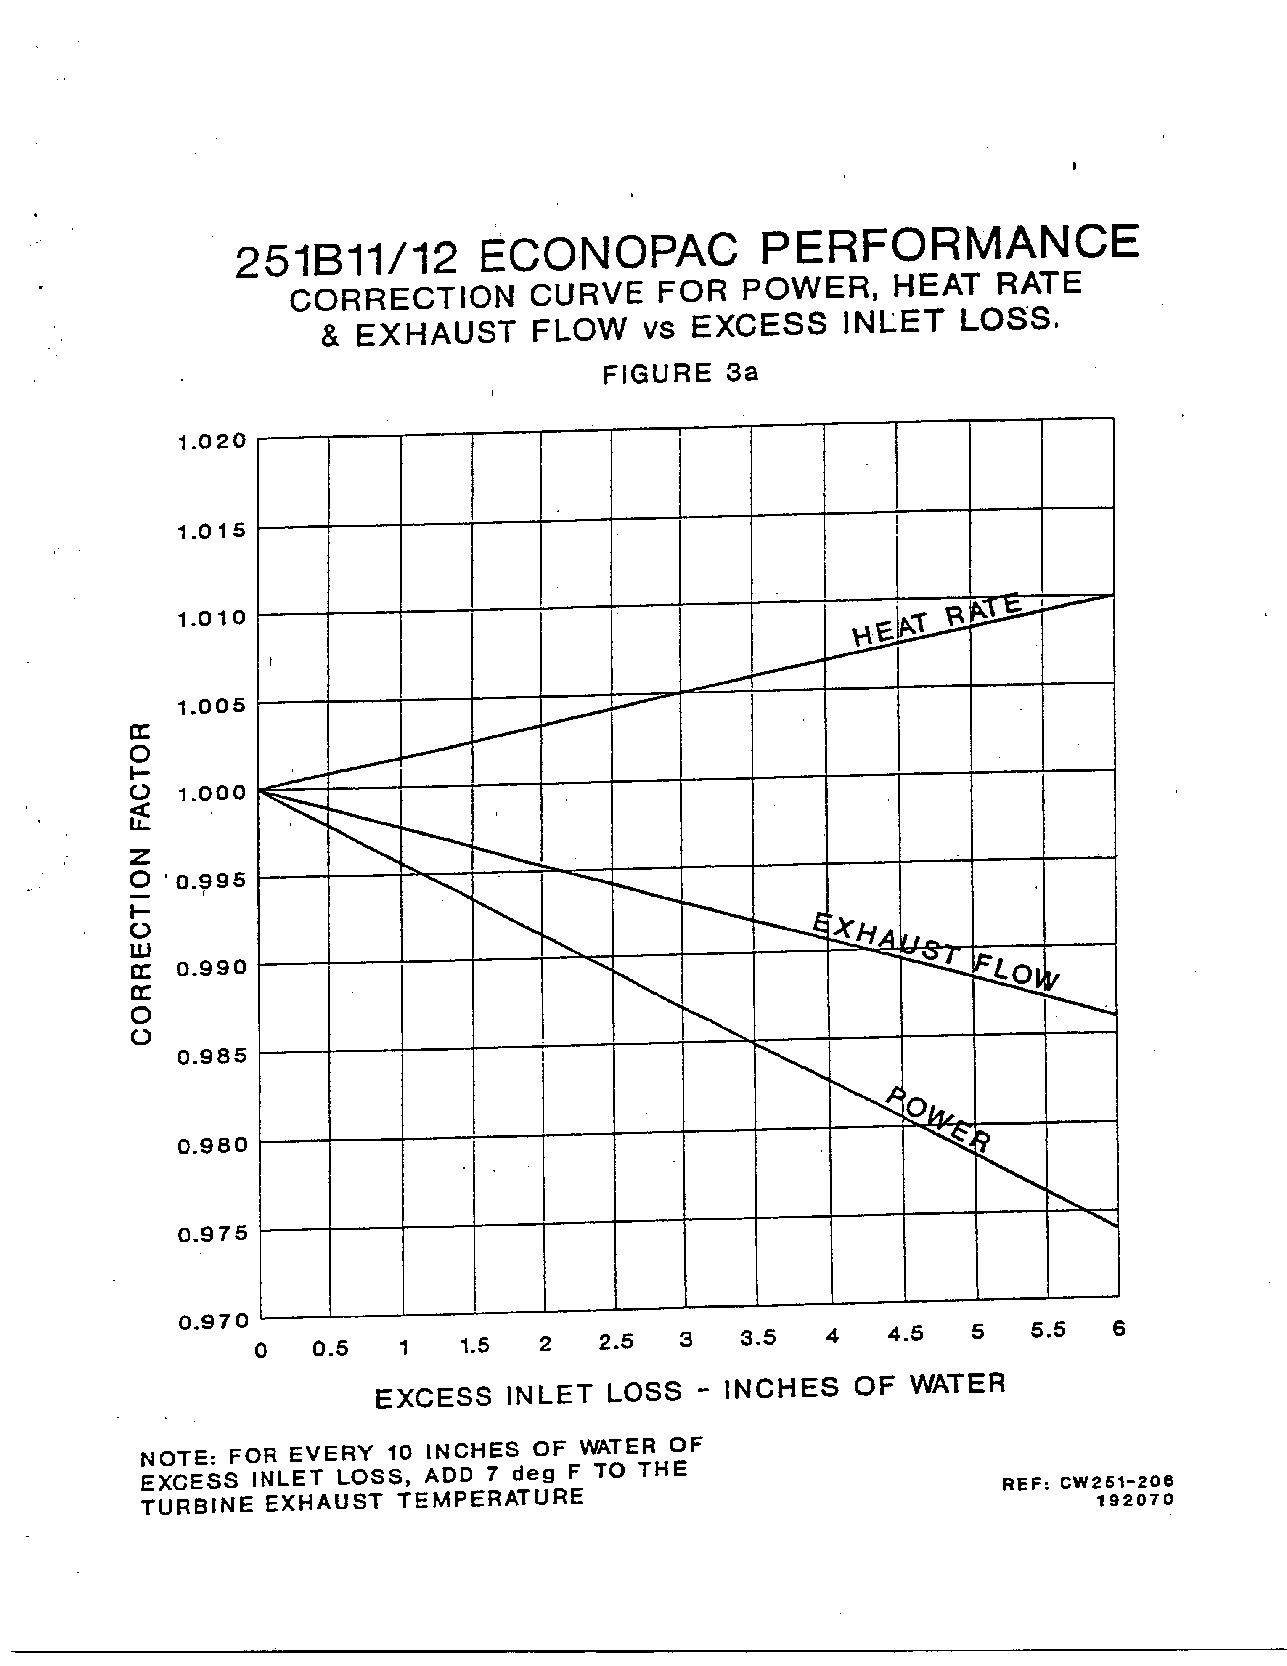

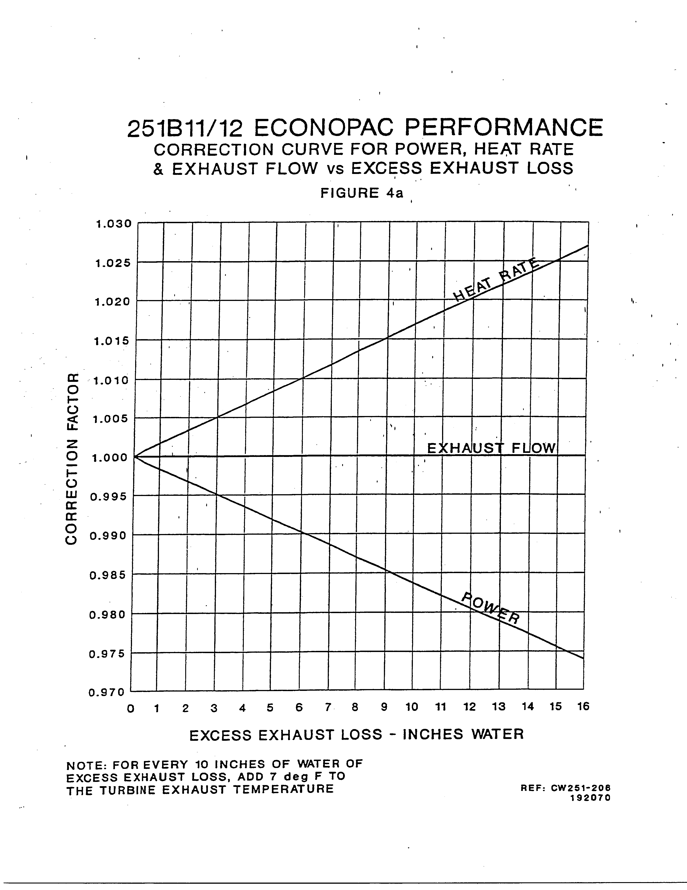

**Case Study 3: Part load and hot day Performance:**

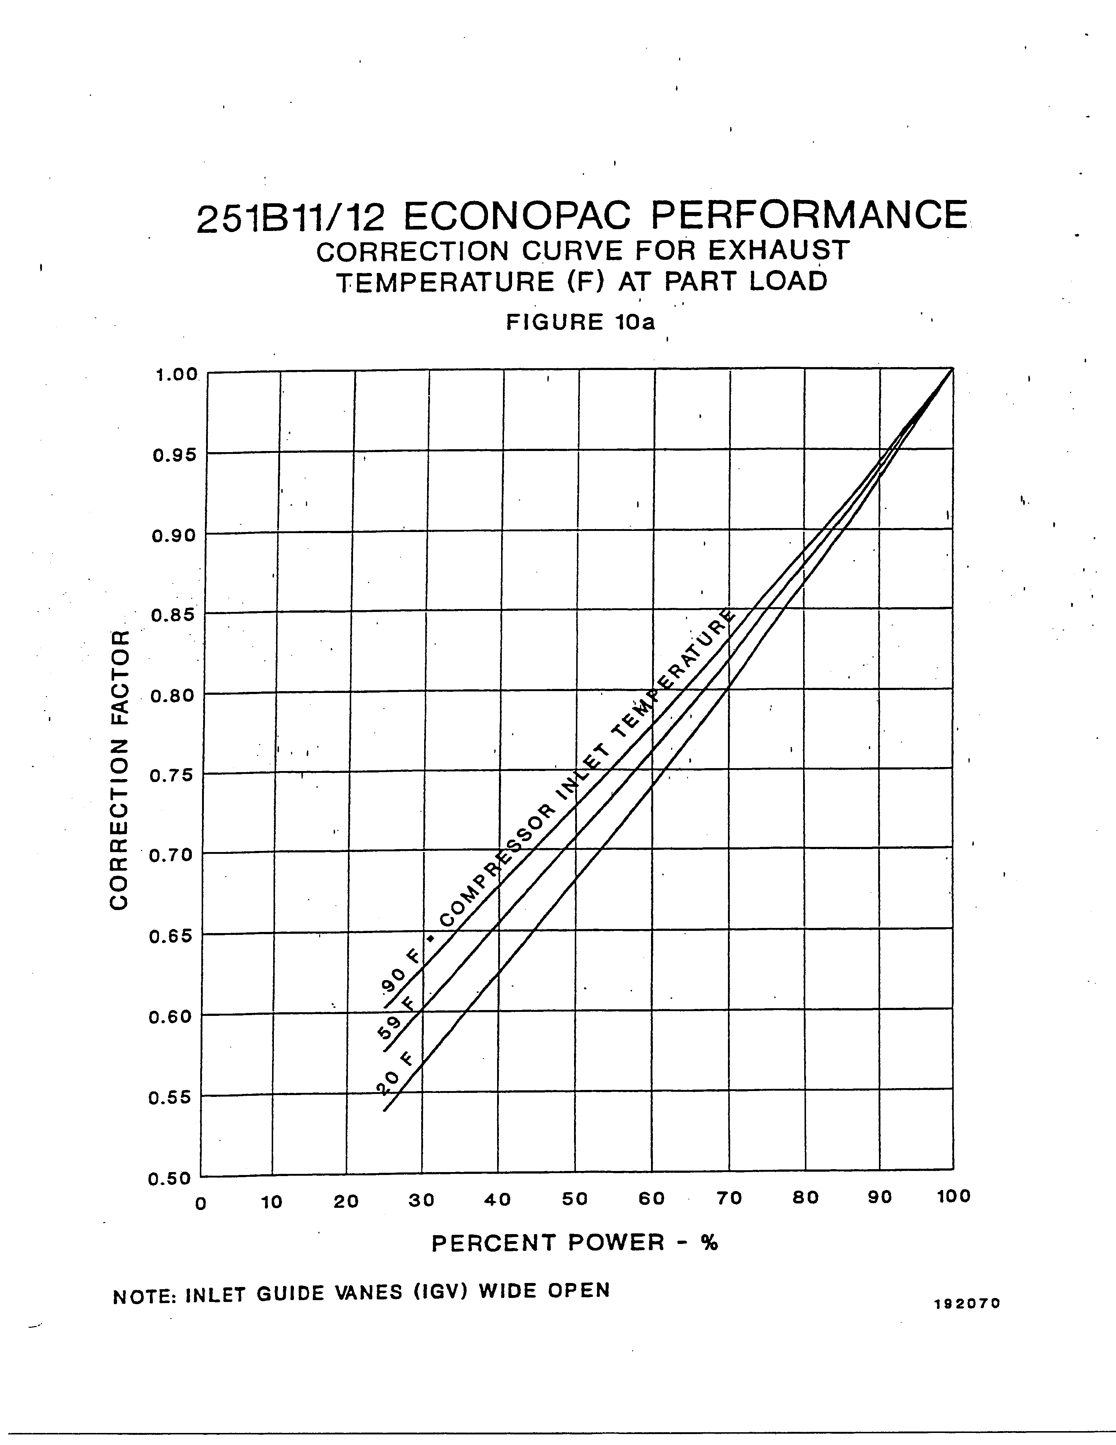

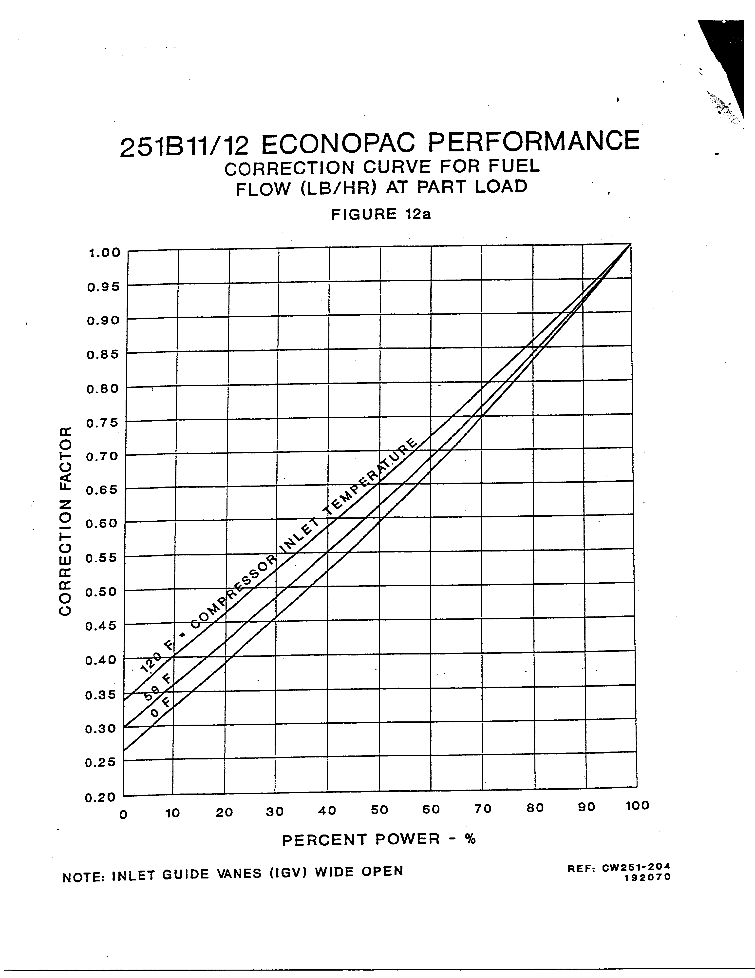

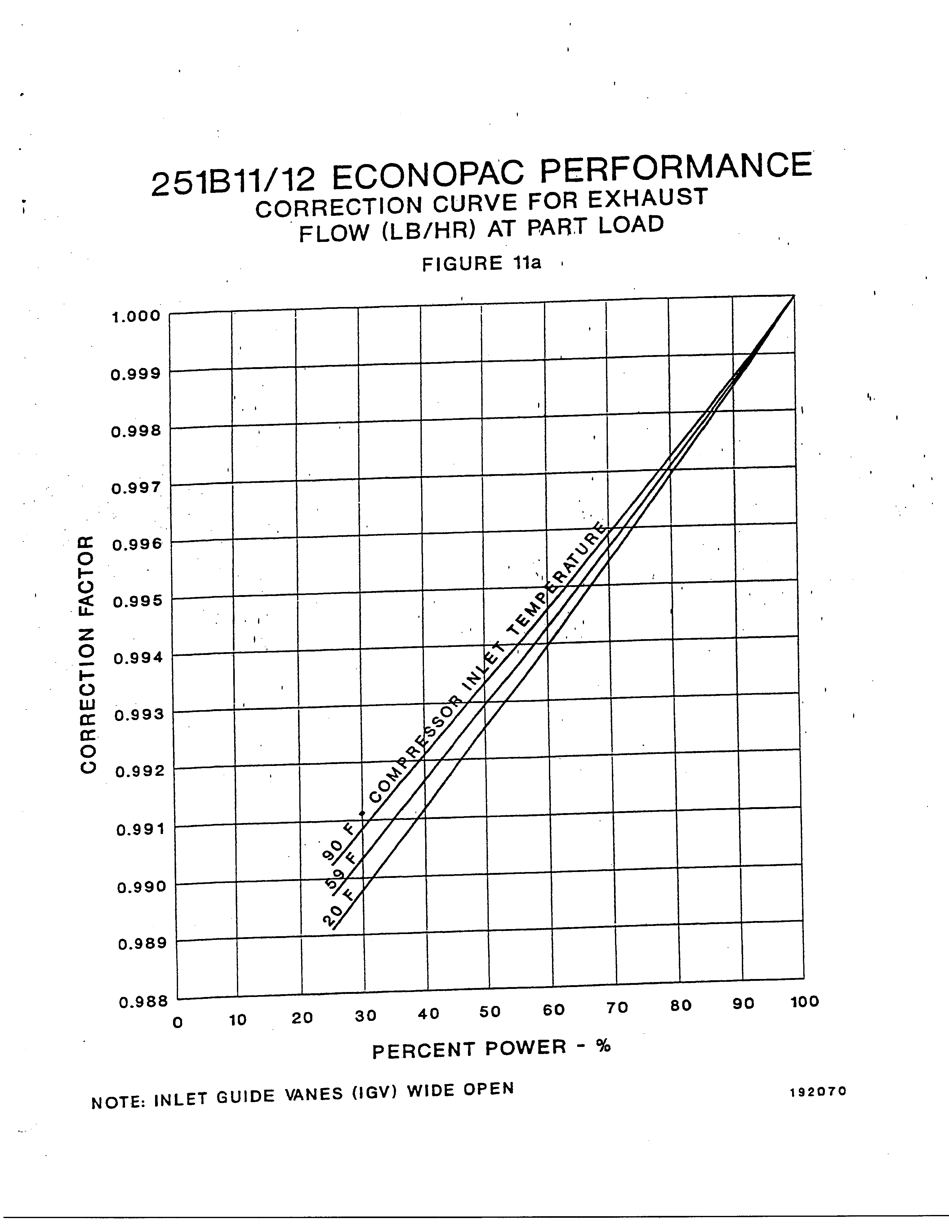

**Case Study 4: Effect of evaporative cooler:**

**Case Study 5: Exergy of the exhaust gases:**

Running the MATLAB code for the base case scenario at full load, an exergy value of 31.7MW is computed, and the net electric power output of the system is given as 48 MWe. Therefore, 66.04% of the net electric power output is lost to the environment instead of contributing positively to the system. Coupling a co-generation system with the W251B system would reroute some, if not all, of the lost energy back into the system. This would increase the overall system efficiency and lower the system’s effect on the environment by reducing the amount of emissions released to the atmosphere. The initial cost of the cogeneration system will depend on what exact system will be added to the Westinghouse system. This cost, compared to the increase in efficiency of the overall system, will determine whether or not the addition of the cogeneration system can be justified. From our research described above, we believe that adding a cogeneration system would be justified.

References

Boyce, Dr. Meherwan P., P.E. *Handbook for Cogeneration and Combined Cycle Power*   
     *Plants*. New York: ASME Press, 2002. N. pag. Print.

Hu, S. David, Ph.D. *Cogeneration*. Reston, VA: Reston Publishing Company, Inc.,   
     1985. N. pag. Print.

Meador, Roy. *Cogeneration and District Heating: An energy-efficiency*   
     *partnership*. Ann Arbor, Michigan: Ann Arbor Science Publishers, Inc.,   
     1981. N. pag. Print.

Poullikkas, Andreas. "An overview of current and future sustainable gas turbine   
     technologies." *Renewable and Sustainable Energy Reviews* 9 (May 2004):   
     409-443. *Academic Search Complete*. Web. 4 May 2011.

Schmidt, Philip, et al. *Thermodynamics: An Integrated Learning System*. Hoboken,   
     NJ: John Wiley & Sons, 2006. N. pag. Print.

Westinghouse. *251B11/12 Econopac Application Handbook*. N.p.: n.p., n.d. Print.

Property Calculator Assignment

Appendix:

* Presentation of hand calculations
* Copy of Matlab script including property calculator

Extra material that we may want to include

Appendix

Equations